Observed and dark diversity dynamics over millennial time scales: fast-life history traits linked to expansion lags of plants in Northern Europe

Diego P.F. Trindade1, Carlos P. Carmona1, Triin Reitalu1,2, & Meelis Pärtel1

1 Institute of Ecology and Earth Sciences, University of Tartu, Juhan Liivi 2, 50409, Tartu, Estonia

2 Institute of Geology, Tallinn University of Technology, Ehitajate tee 5, Tallinn 19086, Estonia.

Author note

Correspondence concerning this article should be addressed to Diego P.F. Trindade, Postal address. E-mail: [diego.trindade@ut.ee](mailto:diego.trindade@ut.ee)

Abstract

Global change drivers (e.g. climate and land-use) affect the species and functional traits observed in a local site but also its dark diversity — the set of species and traits locally suitable but absent. Dark diversity links regional and local scales and, over time, reveals taxa under expansion lags by depicting the potential biodiversity that remains suitable but is absent locally. Since global change effects on biodiversity are both spatially and temporally scale-dependent, examining long-term temporal dynamics in observed and dark diversity would be relevant to assessing and foreseeing biodiversity change. Here we used sedimentary pollen data to examine how both taxonomic and functional observed and dark diversity changed over the past 14500 years in Northern Europe. We found that taxonomic and functional observed and dark diversity increased over time, especially after the Late Glacial and during the Late Holocene. However, dark diversity dynamics revealed expansion lags related to species’ functional characteristics (dispersal limitation and stress intolerance) and an extensive functional redundancy when compared to taxa in observed diversity. We highlight that assessing observed and dark diversity dynamics is a promising tool to examine biodiversity change across spatial scales, its possible causes, and functional consequences.

*Keywords:* Biodiversity change, Dispersal limitation, Functional diversity, Time-lags, Sedimentary pollen, Species pools, Temporal dynamics

Observed and dark diversity dynamics over millennial time scales: fast-life history traits linked to expansion lags of plants in Northern Europe

# 1. Introduction

Global changes (e.g. climate and land-use change) are causing high extinction and migration rates of species, threatening ecosystem functionality, stability and, consequently, human well-being. These changes can reshuffle biodiversity worldwide by modifying the way species disperse, cope with environmental conditions and interact locally (i.e. community assembly processes) [1]. Traditionally, community assembly processes have been examined, across space and time, through the lens of the species pool concept, on the reasoning that a local site is usually a subset of those species in the region able to colonize and cope with the local environmental conditions (i.e. ecological filtered species pool) [2,3]. The ability of species to colonize and cope with local environmental conditions is mediated by their functional traits – measurable characteristics of an individual organism [4]. Thus, in a given time period, the filtered species pool is composed by species in the region displaying certain traits that enabled them to colonize and establish locally (observed diversity), and species that are in the region and theoretically able to colonize and cope with a given site’s condition, but locally absent (dark diversity) [5]. Comparing the traits in observed and dark diversity enables us to understand why these species are suitable but absent and how the filtering process operates from regional to local scales (i.e. favoring or jeopardizing certain set of traits) [6–8]. Since global changes alter the dispersal and suitability of species and traits across space and time, quantifying and foreseeing biodiversity change using taxonomic and functional species pool dynamics is crucial but still incipient in ecology [9–11].

Global change effects on biodiversity are both spatial and temporal scale dependent [12–14]. In that sense, dark diversity offers an operational link between regional and local scales by depicting the set of locally absent species that are ecologically suitable and present in the surrounding region [15]. Additionally, with observed and dark diversity, it is possible to calculate how much of the species pool is locally realized after excluding larger scale processes (i.e. environmental filtering) [16,17]. Over time, dark diversity is expected to change as soon as environmental or biotic conditions change, since it is based on species suitability [18]. However, by depicting those suitable but locally absent species, dark diversity reveals species facing delays in colonization or establishment in the new favorable local site – expansion lag in their range [18,19]. Complementary, based on observed and dark diversity dynamics, the community completeness can be used to examine how fast or slow the species pools are changing [20]. For instance, if the species pool size increases and community completeness decreases over time (i.e. dark diversity increasing relatively more and/or faster than observed diversity), it indicates that more species are being incorporated into the species pool but they are mostly persisting in dark diversity, not expanding their potential range.

In order to detect species pool dynamics and likely delays, long-term datasets representative of a whole region are required [9–11]. Although recent time-series datasets are becoming available and highly useful to test temporal vegetation dynamics, they are relatively short in temporal duration [21]. Alternatively, sedimentary pollen data has been used to describe plant diversity dynamics over millennial time scales, reflecting plant diversity reasonably well [22,23] and providing important hints on how biodiversity may respond in the future [24]. For instance, sedimentary pollen records have shown an increase in observed diversity after the transition from the Late Glacial period (14500 - 11650 cal. yr BP – calibrated years before present where present is 1950) to the early Holocene (11650 - 8200 cal. yr BP) due to warmer conditions [24,25]. Fluctuations in climatic conditions and an increase in human activities over the Holocene have increased the number of taxa, both in terrestrial and oceanic island ecosystems, as well as changed the trait profile of local communities [26,27]. In Europe, during the Late Holocene (~4000 cal. yr BP), the introduction of agriculture created open landscapes and led to significant reductions in average height and seed size of plants by introducing herbaceous taxa and suppressing taller and large-seeded plants [25,28]. Although these patterns are well documented in observed palaeodiversity, no studies have examined how these changes affected the suitability of species and, thereby, the dark diversity of local sites. However, theoretically, a similar overall pattern visible in taxonomic observed diversity of sedimentary pollen can be expected in dark diversity. For example, taxonomic dark diversity is expected to be low under harsher conditions, such as the LG period, because just a few species in the region would be able to cope with the extreme environmental conditions (i.e. low suitability) [8]. As soon as conditions become more favourable (e.g. Early Holocene), more niches are created, increasing both the importance of biotic interactions (i.e. local competition) as well as the number of species in observed and dark diversity [29,30]. Palaeoecological studies have shown that although biodiversity has tracked climate changes relatively fast in the past, some species might have faced some expansion lags – either due to dispersal or establishment limitations [11,31]. These species were likely in dark diversity, and some functional traits may have hampered their colonization or establishment (i.e. poor dispersers and/or weak competitors).

Different functional traits can indicate mechanisms behind absences of plant taxa. For example, taller plants tend to disperse propagules at longer distances and intercept more light than shorter plants [32–34]. Large-seeded species produce fewer seeds but have better chances of establishing during the seedling phase [35,36] and usually have different vectors (i.e. animals, water etc.), enhancing their long-distance dispersal [37–39]. Recent palaeoecological studies, for instance, have suggested that species with high seed mass were more likely to be able to track climate changes over the Holocene due to zoochory (i.e. animal dispersal) [10,40]. Traits related to leaf economics, such as specific leaf area (SLA), help with examining the trade-off between growing fast by producing softer tissues (resource-acquisitive strategies - high SLA) or growing slow but being more stress tolerant (conservative strategies - low SLA) [41]. Thus, depending on the environmental and biotic conditions, some traits can be favoured to the detriment of others. For instance, it is expected that during harsher climatic conditions, traits related to fast life history strategies (shorter plants with high SLA) were either unsuitable or in lower frequency in dark diversity, due to stronger environmental filters [25]. However, as soon as conditions change towards more benign climatic conditions and human intervention, it is likely that taxa with faster life histories moved from dark diversity to observed diversity, being favoured by their resource acquisitive characteristics [28]. Contemporary studies comparing the mean trait values of plant species in observed and dark diversity have shown that species mostly found in dark diversity are those dispersal limited and displaying a lower stress tolerance [6,7]. However, whether this pattern is conserved over millennial time scales, or changes in climatic and human impact affected these trait dynamics in the species pool is still unknown.

Variation in single functional traits can be analysed in combination and summarized by calculating the functional diversity of local communities. In that way, the functional structure of local communities can be viewed as a n-dimensional functional space where species occupy different portions of this space depending on what their traits are [42,43]. Although the notion of functional observed diversity and space is well established in ecology, only recently studies started moving from theoretical exercises [44–46] to empirically test the idea of “functional dark diversity” [47,48]. Similar to the taxonomic species pool, we propose that the functional space of the local pool can be viewed as the functional space occupied by species present in the local community (functional observed space), and the portion of functional space that could be theoretically locally occupied but is absent (functional dark diversity) (Fig. 1). In this way, species in taxonomic dark diversity occupying the same functional space of species already present (functional observed diversity) do not contribute to the functional dark diversity but are functionally redundant. Such a functional redundancy between observed and dark diversity could be an indication of higher stability and resilience of the local communities, since the species in dark diversity are in the surroundings playing a similar functional role as the species locally present, being theoretically able to buffer any potential functional loss [49–51]. Considering functional dark diversity can be particularly important when local extinctions and colonization balance each other, resulting in no net change in species richness [18,52], but the set of extinct and colonizer species differ functionally. Such a scenario, which could lead to drastic changes in the functional profile of communities and largely affect ecosystem functioning, cannot be detected when considering only species’ taxonomical identities [51].

Here we explored the dynamics of observed and dark diversity, pool size and community completeness both at the taxonomic and functional diversity facets using a sedimentary pollen data from Northern Europe. This data spans the last 14500 years from the Late Glacial (LG) period until the present, a period during which the region has experienced significant changes in both climate and human land use [25]. We expect that (1) taxonomic and functional observed and dark diversity (and consequently species pool size) of sedimentary pollen have increased over time, especially after the LG period due to the more benign conditions provided by warmer climate and during the Late Holocene due to higher habitat heterogeneity created by human impacts. (2) We expect that the number of taxa in dark diversity increased faster than in observed diversity since the colonization and establishment of taxa might have been slower than the appearance of suitable habitat conditions. Consequently, we expect a decrease in taxonomic and functional community completeness of sedimentary pollen with time, indicating an expansion lag in taxa range. Finally, (3) since traits linked to low dispersal capacity and stress intolerance are usually the reasons why plant taxa are in dark diversity, we expect that, over time, when compared to observed diversity, dark diversity taxa consisted mostly of shorter plants with small seeds (dispersal-limited) and large leaves (stress-intolerant taxa).

# 2. Methods

## (a) Study area and sampling

Here we used a sedimentary pollen data set described in Reitalu et al. [25], compiled from 20 palaeoecological case studies (comprising 1061 samples and 140 pollen taxa) in Northern Europe (Estonia and Latvia) (56-60° N, 22-28° E — Table S1) [25]. The study area is located between the boreal and nemoral forest zones, consisting mostly of *Picea abies*, *Betula pendula*, *Populus tremula* and *Pinus sylvestris* [53]. This region has experienced important changes in both climate and human impacts over millennial time scales, with marked effects on vegetation dynamics [54]. We used the same chronologies reported in Reitalu et al. [25], which was based on IntCal09 calibration dataset [55] and the OxCal 4.1 program [56], combining radiocarbon ages and lithological data with sedimentary deposition models [57]. To avoid samples with large age uncertainties, only the samples for which the standard deviation of the age estimate did not exceed 100 years were kept in the analysis. The temporal range covered by each site can be seen in Fig. S4.

Following Reitalu et al. [25], we excluded some taxa from the Late Glacial period (earlier than 11650 cal. yr BP) since they are assumed to be re-deposited from older deposits (*Corylus*, *Tilia*, *Quercus*, *Ulmus*, *Fraxinus*, *Alnus* and *Carpinus*) [58]. Because pollen data does not directly reflect species proportions in the vegetation, with high pollen producers being overrepresented [22,59], some palaeoecological studies use methods to downweighting the high pollen producers prior to calculating diversity estimates (i.e. Andersen Transformation) [60]. We did test the use of Andersen-transformed pollen counts, but present the results based on the raw data because there was almost no difference between raw and transformed results (Fig. S9). We also calculated the sample coverage (the expected proportion of identified pollen grains in a sample [61]), which was always very high (0.98), indicating that the taxa recorded were not strongly biased by differences in sampling effort.

## (b) Dark diversity estimation

Dark diversity was estimated using the hypergeometric method in the R-package “DarkDiv” [62]. The hypergeometric method compares the realised number of co-occurrences between pairs of species with random expectations (i.e. no association between species). This information was used to construct a taxa × taxa indication matrix reflecting the fact that taxa occurring in the same samples likely share similar ecological conditions. Using this indication matrix, the algorithm calculates the mean indication for all absent taxa, using present taxa as indicators. This way, we can assign to all absent taxa in a given site a probabilistic estimation that the taxa belong to the dark diversity [63]. The probability for any given taxon is high if the present taxa are generally positively associated with the considered taxon i.e. they tend to co-occur more than expected by chance [63]. To include the maximum amount of co-occurrence information, we used the whole data set to estimate the indication matrix between pairs of taxa. To obtain conservative discrete dark diversity estimations, we only kept taxa with >90% probability according to the hypergeometric method. Such a threshold can be considered rather conservative, since probabilities closer to 50% mean either neutrality or noise in the data, whereas higher probabilities suggest that the number of co-occurrences between the absent and present taxa is greater than expected by chance [63]. In addition, we considered as part of dark diversity of sedimentary pollen only taxa recorded in any sample during 500-year time windows. Such a filter defined dark diversity without considering taxa that have not yet arrived in the region or have been regionally extinct. To assess how realized the local biodiversity was in each local site, excluding the effects of environmental filtering, we also calculated taxonomic completeness for each sample as follows: log(observed diversity / dark diversity) [16].

## (c) Sensitivity analyses

Pollen-based samples have inevitably imperfect coverage of real biodiversity, and study sites originate from non-random locations where pollen have preserved. Although we detected a high sample coverage in our samples, we additionally tested how much the sampling coverage could be affecting species co-occurrences and thus the dark diversity estimation. We simulated better sampling coverage by adding a different percentage of absences (2%, 5%, 10%, 15%, 20% and 25%) using taxa’s dark diversity probability in absent sites as likelihood to be included as “present”. In such a way, we “sampled” additionally taxa which were likely to occur in a site [64]. We used co-occurrences from such a dataset, but actual present species as indicators, and re-estimated the dark diversity. The obtained dark diversity sizes were highly similar to the these used originally (Fig. S5). To test the effect of spatial autocorrelation, we performed a Mantel test (Bray-Curtis dissimilarity on binary data from study sites vs. their geographical distance), which was non-significant (r = 0.1; p = 0.14), suggesting that closer sites were not more taxonomically similar. In addition, we calculated co-occurrences in a dataset where we removed spatially closest sites. Again, we re-estimated dark diversity using these co-occurrences but originally recorded taxa as indicators. The obtained dark diversity was very similar to the original values (Fig. S6). We concluded that the current dataset was robust against sampling coverage and non-random spatial distribution of study sites.

## (d) Functional traits

We considered four functional traits linked to species dispersal, establishment and persistence of plants: clonality, maximum height, specific leaf area (SLA), and seed weight. Clonality is linked to species persistence and favors short distance dispersal of plants [65,66]. Plant height and seed weight are linked to species dispersal, establishment and persistence, given that taller species have usually higher competitive and dispersal abilities [32,34]. Large-seeded species typically produce fewer seeds but have stronger establishment ability [35,36,67] and, when having efficient vectors (i.e. animals, water etc.), disperse over longer distances [38,39]. Finally, SLA is mostly related to stress tolerance, with species having low SLA being more conservative in resource use (high stress tolerance), whereas species with high SLA are usually fast growing but have lower stress tolerance [41]. Trait data was obtained from a previous publication [25], in which the trait values were calculated by averaging the trait estimates of species belonging to each pollen taxon.

## (e) Functional observed and dark diversity

To characterize the multidimensional functional trait space of observed diversity, we first log-transformed the trait data to diminish the effect of outliers and reduce skewness, and then performed a Principal Component Analysis (PCA) with the scaled trait values for each taxon. We used the first two components of the PCA (which explained 71% of the total trait variation) to define a 2-dimensional functional space [42] and used the scores of taxa in these components as indicators of the functional traits of taxa. We then estimated a trait probability density (TPD) [42,68] for each taxon as a bivariate normal distribution centred in the scores of the taxon and with a standard deviation (bandwidth) that was chosen using the plug-in bandwidth selector available in the *ks* R package [69]. Using the *TPDc* function from R package “TPD” [68], we combined i) the TPD functions of the taxa present in each sample, and ii) the TPD functions of the taxa classified as belonging to the sample’s dark diversity, obtaining TPD functions for the observed and dark diversity of each sample, respectively. These functions reflect the relative abundance of each combination of traits in a given community (i.e. the “observed” and “dark” functional structure of each sample). We then applied a 99% probability threshold to these TPD functions and estimated the amount of functional space occupied by observed and dark diversity in each community at each time period (functional richness). In the case of functional dark diversity, we are only interested in the portions of functional space that are not already occupied by taxa present in observed diversity. For this, we overlapped the functional space occupied by the observed taxa with the functional space occupied by taxa in dark diversity, and then considered the functional dark diversity as the unique portion of this overlapped functional space (see Fig. 1). Finally, similarly to the taxonomic completeness, we calculated the functional completeness as the log(functional observed diversity / functional dark diversity).

## (f) Statistical analysis

We used generalized additive models (GAMs) to identify how taxonomic and functional observed diversity, dark diversity, species pool size and community completeness, as well as mean trait values changed over time, using the package *mgcv* in R [70]. Individual GAMs were fitted for each component of each diversity facet (taxonomic and functional), resulting in six GAM models: taxonomic richness, taxonomic completeness, functional richness, functional completeness, and mean values for each dimension of the functional space. Age (calibrated years before present, fitted using a cubic spline smoother) was used as the independent variable in all models. In the models in which the independent variable can be estimated for each diversity component (observed diversity, dark diversity, species pool; i.e. all models except those for completeness), we used the diversity component as a factor, so that a separate smoother was created for each diversity component; this allowed us to describe differences in the temporal patterns of the different components. Since all individual smoothers considered for each diversity component (observed, dark and pool size) responded differently, we kept the individual smoothers in all GAM models. Thus, a general GAM model was fitted as follows: gam(y ~ divComponent + s(Age, bs = “cr”, by=divComponent)), being “divComponent” the factor variable grouping observed diversity, dark diversity and species pool size.

Data cleaning, analysis, visualization and writing was performed in R, using the following R packages: *papaja* [71], *renv* [72], *here* [73], *dplyr* [74] and *flextable* [75].

# 3. Results

In total, 140 taxa were identified in our dataset, from which 94 taxa were found in dark diversity over the whole period examined. *Betula, Pinus, Cyperaceae, Poaceae* and *Picea* were the most frequent taxa in observed diversity, whereas *Asteraceae (Liguliflorae), Frangula, Plantago lanceolata, Fagus* and *Ranunculus* were the ones most found in dark diversity over the whole period (see Fig. S7 for frequencies of taxa in observed and dark diversity over time).

The first dimension of the functional space (explaining 46.7% variance) reflected differences among species in size (seed mass and height) and clonality, whereas the second dimension (24% variance explained; Fig. S5) showed differences in leaf economics. The extremes of the functional space in the first axis were represented by *Quercus* and *Fagus*, which include tall species with heavy seeds, whereas *Drosera* and *Saxifraga* represented the opposite extreme (i.e. shorter stature and lighter seeds). Likewise, in the second axis, *Trientalis* and *Circaea* represented taxa with high SLA, whereas *Pinus* and *Empetraceae* represented the opposite extreme, low SLA (see Fig. S8).

## Taxonomic observed and dark diversity and community completeness dynamics over time

Both taxonomic observed and dark diversity increased over time in Northern Europe, especially after the Late Glacial period and during the Late Holocene (R2 = 0.81, p = <0.001; see Table S1 for full statistic results). During the Early Holocene, both observed and dark diversity continued increasing, but dark diversity decreased at the end of the Early Holocene (ca. 8200 cal. yr BP). After the first half of the Mid-Holocene, dark diversity increased before and faster than observed diversity, but both followed similar patterns during the Late Holocene, increasing from ~4000 cal. yr BP, with a sharp increase from 500 cal. yr BP (Fig. 2A).

Taxonomic completeness decreased from the LG towards the Early Holocene, became stable during the transition between the Early Holocene and Mid-Holocene (~8300-7000 yBP) and continued decreasing from the Mid-Holocene until the present (R2 = 0.19, p = <0.001; see Table S2 for full statistic results).

## Functional observed and dark diversity and community completeness dynamics over time

Functional observed and dark diversity increased over time (R2 = 0.97, p = <0.001; Table S3 for full statistic results). Specifically, functional observed diversity increased after the Late Glacial, did not change from 10000 cal. yr BP until 5500 BP, and increased again during the Late Holocene. Functional dark diversity increased after the Late Glacial until the end of the Early Holocene, became stable during the Mid-Holocene, slightly increased again during the Late Holocene (~2000 cal. yr BP) and decreased afterwards.

Functional completeness decreased from the Late Glacial towards the Early Holocene and stayed roughly stable over the Mid and Late Holocene (R2 = 0.05, p = <0.001; see Table S4 for full statistic results) (Fig. 2B).

## Mean functional trait values over time

Compared to taxa in observed diversity, taxa in dark diversity had generally lower scores in the first PCA axis (related to short stature, lighter seeds and higher clonality ability; R2 = 0.70, p < 0.01), and higher scores in the second axis (related to large specific leaf area; R2 = 0.50, p < 0.01). After the Late Glacial period, taxa became taller, with larger seeds, lower clonality ability and larger leaves (Fig. 3) (see Table S5-6 for full statistic results).

# Discussion

Our study provides the first assessment of taxonomic and functional species pool dynamics (observed and dark diversity) over millennial time scales, highlighting taxonomic and functional dark diversity as complementary and promising tools to reveal how much, how fast, and in what direction species pools have changed. Using a pollen dataset from Northern Europe, we show that both observed and dark diversity increased after the Late Glacial period along with warming climate and over the Holocene following both climatic fluctuations and increased human activities. However, taxonomic dark diversity increased generally faster than observed diversity over the Holocene (resulting in decreasing taxonomic completeness), suggesting that the rate at which climate warming and human impacts increased habitat availability outpaced the ability of several taxa to expand their realised range (i.e. expansion lag). Such an expansion lag can be linked to the functional aspects of dark diversity. First, most taxa incorporated into dark diversity over time were functionally redundant compared to taxa in observed diversity (i.e. high overlap in the functional space of observed and dark diversity). Second, by comparing mean functional trait values in observed and dark diversity, we show that taxa in dark diversity mostly displayed fast life-history strategies, likely reflecting dispersal limitation (low height, small seeds, high clonality) and stress-intolerance (high SLA). Thus, since taxa in dark diversity were generally more dispersal limited and stress intolerant, they either had more difficulties in reaching the local sites or, when able to arrive, had to compete with stronger competitors already occupying their potential niche.

We expected to observe increases in both taxonomic and functional observed and dark diversity after the Late Glacial period because colder climate acts as a strong environmental filter, whereas more benign climatic conditions increase the number of species and range of trait values suitable for a region [76–78]. In agreement with this expectation, taxonomic observed and dark diversity displayed an increase over the Holocene, showing the role of Early Holocene climate warming in increasing niche availability (i.e. beta-niche), and suggesting that humans acted as important niche constructors during the Late Holocene [79]. Despite the overall increase of taxonomic observed and dark diversity, the decreasing taxonomic community completeness trend suggests that taxonomic dark diversity increased earlier and faster than observed diversity. The faster increase in dark compared to observed diversity suggests that climate and human activities increased the number of sites suitable for many taxa faster than what potential biodiversity could realise locally, indicating expansion lag [31]. For instance, our estimations suggest that many locations became suitable to some taxa during the first half of the Mid-Holocene, but these taxa realised locally centuries later (i.e. *Brassicaceae, Frangula, Plantago lanceolata* - Fig. S7). Although evidence suggests that plant species have tracked suitable local conditions relatively fast in periods of extensive climatic and land-use change (i.e. post-glacial and Late Holocene), periods of high climatic stability (i.e. Mid-Holocene) may have increased the importance of competition at local sites, hindering some taxa from establishing or persisting [80]. During the Late Holocene, the rapid and sharp increase in observed and dark diversity is likely linked to human activities: increased landscape openness (e.g. slash-and-burn agriculture and established farming practices, ca 3800-1200 cal. yr BP) and reduced dispersal limitation with a rapid introduction of several taxa [54]. Thus, human impacts have increased not only observed diversity, as well documented for NE Europe and globally [26,27], but the size of the whole taxonomic pool, facilitating the establishment of some taxa but also creating suitable conditions to many other taxa in the surrounding region [79].

Periods of increasing taxonomic pool sizes (i.e. after the Late Glacial and during the Late Holocene) were also related to expansions in the functional pool space, indicating that climate warming and human impact accelerated both the increase of taxa and trait values in NE Europe. Although some functional expansion is expected, since more taxa can be related to higher functional diversity [81], by decomposing the functional space into observed and dark spaces, we show a decoupled pattern in the expansion of the functional space over the Holocene. Accordingly, after the Late Glacial period, the functional space of both observed and dark diversity expanded substantially and rapidly due to benign climatic conditions, allowing the establishment of taxa with new traits and increasing the suitability of taxa with unique trait values in dark diversity. However, during the Late Holocene, the expansion of the suitable functional space came mostly from the observed diversity. On the one hand, such a result suggests that human activities created new niches that were rapidly occupied by taxa with new trait values (mostly herbaceous taxa), whereas functionally redundant taxa stayed in dark diversity (likely suggesting some niche preemption effects [82]). On the other hand, such a high functional redundancy in dark diversity also indicates a high functional species pool stability and potential resilience to disturbances in NE Europe over the Holocene, since local losses could be compensated by taxa playing similar functional roles in the surrounding region [49].

Compared to taxa in observed diversity, over the whole period examined, taxa in dark diversity had on average traits suggesting faster life-history strategies (lower height, lower seed weight and higher SLA). We hypothesize that these fast life-history traits in dark diversity are linked to dispersal limitation and stress intolerance, which, together with the overall functional redundancy, may explain why these taxa presented expansion lags. For instance, several short and large-leaved taxa (e.g. *Asteraceae, Melampyrum, Rumex, Saxifraga* - ruderal and pasture land taxa), appeared in the region, occupied just a few sites and remained suitable but absent from many other potential sites, realizing locally centuries later with the increasing of human impact (~2000 cal. yr BP). In North America, for example, tall and large-seeded species were more likely to have tracked climatic changes over the Holocene, potentially due to the dispersal by large mammals and birds [10,40]. We suggest that, prior to the intensification of agriculture, the same happened in Northern Europe, in which taxa displaying stronger dispersal and persistence abilities either outcompeted or arrived first than dispersal limited and stress intolerant taxa, hampering their establishment in most potential sites [82].

Although these taller and large-seeded taxa thrived over the Holocene, the taxonomic and functional trends in the last 2000 years suggest that the onset and intensification of agriculture have extensively favoured herbaceous taxa (e.g. *Plantago, Rumex, Brassicaceae, Humulus*) [25,28]. Thus, increased human impact enabled some resource-acquisitive taxa (e.g. ruderal and pasture land taxa), previously mostly in expansion lag, to realize locally. Since our focus is to reconstruct observed and dark diversity dynamics of sedimentary pollen, and the correlation between pollen samples and contemporary vegetation in the region is not perfect [22], the future consequences of that potential shift in the species pool’s trait profile to the ecosystem functioning of NE Europe should be considered cautiously. However, different studies have already warned that humans are mostly favoring resource-acquisitive strategies, having important environmental and evolutionary consequences to biodiversity [83,84]. Those consequences include accelerating nutrient cycling, increasing productivity and biomass turnover, as well as herbivory and sensitivity to drought events, affecting ecosystems services and functioning [85,86]. Although focused on millennial time scale patterns, our results are in line with recent evidence suggesting dark diversity as a promising tool to assess and foreseeing biodiversity change in the Anthropocene [8,11,87].

Inferring taxonomic and functional vegetation dynamics using sedimentary pollen data is usually challenging due to the taxonomic resolution of pollen samples (e.g. some taxa described at genus or family levels), presence of non-detected taxa, over-representation of some taxa, as well as clumped distribution of study sites where pollen is preserved [88,89]. All these factors can also affect dark diversity estimations using co-occurrence data. However, we tried to minimize those limitations by including in dark diversity only taxa with high suitability (> 90% probability), as well as performing sensitivity analyses by imputing highly suitable taxa in observed and testing for spatial autocorrelation (S5-6). In our study, neither imputing “unrecorded” taxa nor spatial autocorrelation had a large effect on dark diversity estimations. Thus, the current dataset was robust against sampling and spatial issues, but we encourage other studies to consider similar sensitivity analyses to test whether these issues are affecting dark diversity estimations. In addition, the functional space considered in our study depends on the number of taxa and traits available. Nevertheless, the fundamental characteristics of the functional space we described are similar to those of the contemporary global spectrum of plant form and function, including two fundamental axes of variation comprised by the plant size (contributed by plant height, seed mass and clonality) and leaf economics spectra (contributed by specific leaf area) [34,51]. Thus, we are convinced that the functional space described here is representative and has been conserved in NE Europe over millennial time scales.

# Conclusions

Climate warming and human activities have boosted the diversity of plants over millennial time scales in NE Europe. However, dark diversity patterns suggest that several taxa experienced a delay in their range expansion due to a high functional redundancy as well as dispersal limitation and stress intolerance when compared to taxa in observed diversity. Here we highlight that species pools and their components – observed and dark diversity – are highly dynamic biodiversity components with their own temporal patterns. Examining which taxa and traits change over time within the species pool enables to better assess how climate change and human activities alter different ecological filters and, thereby, affect biodiversity change. To conclude, dark diversity is a novel and complementary tool to examine biodiversity change by linking local and regional scales, and revealing temporal lags in biodiversity response to global change drivers.

# Acknowledgemnts

We thank the data contributors of original data to the Neotoma Paleoecology Database, as well as Siim Veski and Anneli Poska for the availability of pollen data. This study was financially supported by the Estonian Research Council (PRG609, PSG293, PRG874, PRG323, and MOBERC40) and the European Regional Development Fund (Centre of Excellence EcolChange).

# Figures



*Figure* *1.*  Conceptual figure depicting how climate, human impact, vegetation dynamics and the functional space of plants changed over the past 14500 years in Northern Europe. Different time periods are depicted with different colours: Late Glacial (in blue); Early Holocene (in green); Mid Holocene (in red); Late Holocene (in yellow). Over time, different climatic (warming period and climatic optimum) and starting point of major human impacts (first traces of humans, beginning of agriculture, increasing population density and modern period), as well as vegetation dynamics are depicted and were reported in different palaeocological studies in NE Europe [54,90]. Bottom panel represents the functional space occupied by taxa in observed and dark diversity (yellow and blue area and points, respectively) in a single site [91] over three different periods (Early Holocene, Mid Holocene and Late Holocene). The functional space is represented by a PCA (two axis), in which the first axis was composed by taxa (points on the graphs) ranging from high stature and seed weight to the opposite traits values and the second axis ranging from small to large leaves. Since dark diversity is defined as the set of species suitable but locally absent, we calculated the functional dark diversity as the area of suitable but locally absent trait space (only the area not overlapping with observed trait space - blue area). Temperature trend (GAM fit line in red and 95% confidence interval - shaded area) was retrieved from PaleoClim [92] and further calculated as the difference of July temperature of each year from pre-industrial July temperature mean. Human population trend (in blue) was retrieved from the Hyde dataset [93] and depicts human population estimates (inhabitants/grid cell (10km) - log transformed).



*Figure* *2.*  Number of taxa (A), functional space (B) in both observed and dark diversity, as well as taxonomic and functional completeness (C, D) of sites in NE Europe over the past 14500 years (cal. yr BP). Lines represent the fits of GAM and shaded areas the 95% confidence intervals



*Figure* *3.*  Mean trait values for observed and dark diversity in NE Europe over the past 14500 years (cal. yr BP). First PCA axis depicts height, seed mass and clonality values, whereas second PCA axis (B) depicts specific leaf area values (SLA). Lines represent the fits of GAM and shaded areas the 95% confidence intervals

# References

1. Pecl G *et al.* 2017 Biodiversity redistribution under climate change: Impacts on ecosystems and human well-being. *Science* **355**, eaai9214. (doi:[10.1126/science.aai9214](https://doi.org/10.1126/science.aai9214))

2. Zobel M. 2016 The species pool concept as a framework for studying patterns of plant diversity. *Journal of Vegetation Science* **27**, 8–18. (doi:[10.1111/jvs.12333](https://doi.org/10.1111/jvs.12333))

3. Götzenberger L *et al.* 2012 Ecological assembly rules in plant communitiesapproaches, patterns and prospects. *Biological Reviews* **87**, 111–127. (doi:[10.1111/j.1469-185X.2011.00187.x](https://doi.org/10.1111/j.1469-185X.2011.00187.x))

4. Dawson SK *et al.* 2021 The traits of “trait ecologists”: An analysis of the use of trait and functional trait terminology. *Ecology and Evolution* **n/a**. (doi:[10.1002/ece3.8321](https://doi.org/10.1002/ece3.8321))

5. Pärtel M, Szava-Kovats R, Zobel M. 2011 Dark diversity: Shedding light on absent species. *Trends in Ecology & Evolution* **26**, 124–128. (doi:[10.1016/j.tree.2010.12.004](https://doi.org/10.1016/j.tree.2010.12.004))

6. Riibak K *et al.* 2015 Dark diversity in dry calcareous grasslands is determined by dispersal ability and stress-tolerance. *Ecography* **38**, 713–721. (doi:[10.1111/ecog.01312](https://doi.org/10.1111/ecog.01312))

7. Moeslund JE, Brunbjerg AK, Clausen KK, Dalby L, Fløjgaard C, Juel A, Lenoir J. 2017 Using dark diversity and plant characteristics to guide conservation and restoration. *Journal of Applied Ecology* **54**, 1730–1741. (doi:[10.1111/1365-2664.12867](https://doi.org/10.1111/1365-2664.12867))

8. Trindade DPF, Pärtel M, Carmona C, Randlane T, Nascimbene J. 2021 Integrating dark diversity and functional traits to enhance nature conservation of epiphytic lichens: A case study from Northern Italy. *Biodiversity and Conservation* **30**, 2565–2579. (doi:[10.1007/s10531-021-02211-w](https://doi.org/10.1007/s10531-021-02211-w))

9. Blonder B *et al.* 2015 Linking environmental filtering and disequilibrium to biogeography with a community climate framework. *Ecology* **96**, 972–985. (doi:[10.1890/14-0589.1](https://doi.org/10.1890/14-0589.1))

10. Knight CA, Blois JL, Blonder B, Macias-Fauria M, Ordonez A, Svenning J-C. 2019 Community assembly and climate mismatch in Late Quaternary eastern North American pollen assemblages. *The American Naturalist*, 000–000. (doi:[10.1086/706340](https://doi.org/10.1086/706340))

11. Rijal DP *et al.* 2021 Sedimentary ancient dna shows terrestrial plant richness continuously increased over the holocene in northern fennoscandia. *Science Advances* **7**, eabf9557. (doi:[10.1126/sciadv.abf9557](https://doi.org/10.1126/sciadv.abf9557))

12. McGill B, Dornelas M, Gotelli N, Magurran A. 2015 Fifteen forms of biodiversity trend in the Anthropocene. *Trends in Ecology & Evolution* **30**, 104–113. (doi:[10.1016/j.tree.2014.11.006](https://doi.org/10.1016/j.tree.2014.11.006))

13. Chase J *et al.* 2019 Species richness change across spatial scales. *Oikos* **0**, 113. (doi:[10.1111/oik.05968](https://doi.org/10.1111/oik.05968))

14. Jarzyna M, Jetz W. 2018 Taxonomic and functional diversity change is scale dependent. *Nature Communications* **9**, 2565. (doi:[10.1038/s41467-018-04889-z](https://doi.org/10.1038/s41467-018-04889-z))

15. Pärtel M, Bennett JA, Zobel M. 2016 Macroecology of biodiversity: Disentangling local and regional effects. *New Phytologist* **211**, 404–410. (doi:[10.1111/nph.13943](https://doi.org/10.1111/nph.13943))

16. Pärtel M, Szava-Kovats R, Zobel M. 2013 Community completeness: Linking local and dark diversity within the species pool concept. *Folia Geobotanica* **48**, 307–317. (doi:[10.1007/s12224-013-9169-x](https://doi.org/10.1007/s12224-013-9169-x))

17. Jiménez-Alfaro B *et al.* 2018 History and environment shape species pools and community diversity in european beech forests. *Nature Ecology & Evolution* **2**, 483–490. (doi:[10.1038/s41559-017-0462-6](https://doi.org/10.1038/s41559-017-0462-6))

18. Trindade DPF, Carmona CP, Pärtel M. 2020 Temporal lags in observed and dark diversity in the Anthropocene. *Global Change Biology* **26**, 3193–3201. (doi:[10.1111/gcb.15093](https://doi.org/10.1111/gcb.15093))

19. Török P, Helm A. 2017 Ecological theory provides strong support for habitat restoration. *Biological Conservation* **206**, 85–91. (doi:[10.1016/j.biocon.2016.12.024](https://doi.org/10.1016/j.biocon.2016.12.024))

20. Gaüzère P, Devictor V. 2021 Mismatches between birds’ spatial and temporal dynamics reflect their delayed response to global changes. *Oikos* **130**, 1284–1296. (doi:[10.1111/oik.08289](https://doi.org/10.1111/oik.08289))

21. Dornelas M *et al.* 2018 BioTIME: A database of biodiversity time series for the Anthropocene. *Global Ecology and Biogeography* **27**, 760–786. (doi:[10.1111/geb.12729](https://doi.org/10.1111/geb.12729))

22. Reitalu T *et al.* 2019 Patterns of modern pollen and plant richness across Northern Europe. *Journal of Ecology* **107**, 1662–1677. (doi:[10.1111/1365-2745.13134](https://doi.org/10.1111/1365-2745.13134))

23. Blaus A, Reitalu T, Gerhold P, Hiiesalu I, Massante J, Veski S. 2020 Modern pollen—plant diversity relationships inform palaeoecological reconstructions of functional and phylogenetic diversity in calcareous fens. *Frontiers in Ecology and Evolution* **8**. (doi:[10.3389/fevo.2020.00207](https://doi.org/10.3389/fevo.2020.00207))

24. Giesecke T, Wolters S, van Leeuwen J, van der Knaap P, Leydet M, Brewer S. 2019 Postglacial change of the floristic diversity gradient in Europe. *Nature Communications* **10**, 5422. (doi:[10.1038/s41467-019-13233-y](https://doi.org/10.1038/s41467-019-13233-y))

25. Reitalu T, Gerhold P, Poska A, Pärtel M, Väli V, Veski S. 2015 Novel insights into post-glacial vegetation change: Functional and phylogenetic diversity in pollen records. *Journal of Vegetation Science* **26**, 911–922. (doi:[10.1111/jvs.12300](https://doi.org/10.1111/jvs.12300))

26. Mottl O *et al.* 2021 Global acceleration in rates of vegetation change over the past 18,000 years. *Science* **372**, 860–864. (doi:[10.1126/science.abg1685](https://doi.org/10.1126/science.abg1685))

27. Nogué S *et al.* 2021 The human dimension of biodiversity changes on islands. *Science* **372**, 488–491. (doi:[10.1126/science.abd6706](https://doi.org/10.1126/science.abd6706))

28. Veeken A, Santos MJ, McGowan S, Davies AL, Schrodt F. 2022 Pollen-based reconstruction reveals the impact of the onset of agriculture on plant functional trait composition. *Ecology Letters* **25**, 1937–1951. (doi:[10.1111/ele.14063](https://doi.org/10.1111/ele.14063))

29. Karger DN, Tuomisto H, Amoroso VB, Darnaedi D, Hidayat A, Abrahamczyk S, Kluge J, Lehnert M, Kessler M. 2015 The importance of species pool size for community composition. *Ecography* **38**, 1243–1253. (doi:[10.1111/ecog.01322](https://doi.org/10.1111/ecog.01322))

30. Paquette A, Hargreaves AL. 2021 Biotic interactions are more often important at species’ warm versus cool range edges. *Ecology Letters* **24**, 2427–2438. (doi:[10.1111/ele.13864](https://doi.org/10.1111/ele.13864))

31. Giesecke T, Brewer S, Finsinger W, Leydet M, Bradshaw RHW. 2017 Patterns and dynamics of European vegetation change over the last 15,000 years. *Journal of Biogeography* **44**, 1441–1456. (doi:[10.1111/jbi.12974](https://doi.org/10.1111/jbi.12974))

32. Thomson F, Moles A, Auld T, Kingsford R. 2011 Seed dispersal distance is more strongly correlated with plant height than with seed mass. *Journal of Ecology* **99**, 1299–1307. (doi:[10.1111/j.1365-2745.2011.01867.x](https://doi.org/10.1111/j.1365-2745.2011.01867.x))

33. Thomson F, Letten A, Tamme R, Edwards W, Moles A. 2018 Can dispersal investment explain why tall plant species achieve longer dispersal distances than short plant species? *New Phytologist* **217**, 407–415. (doi:[10.1111/nph.14735](https://doi.org/10.1111/nph.14735))

34. Díaz S *et al.* 2016 The global spectrum of plant form and function. *Nature* **529**, 167–171. (doi:[10.1038/nature16489](https://doi.org/10.1038/nature16489))

35. Harrison S, LaForgia M. 2019 Seedling traits predict drought-induced mortality linked to diversity loss. *Proceedings of the National Academy of Sciences* **116**, 5576–5581. (doi:[10.1073/pnas.1818543116](https://doi.org/10.1073/pnas.1818543116))

36. Moles A, Westoby M. 2006 Seed size and plant strategy across the whole life cycle. *Oikos* **113**, 91–105. (doi:[10.1111/j.0030-1299.2006.14194.x](https://doi.org/10.1111/j.0030-1299.2006.14194.x))

37. Westoby M. 1998 A leaf-height-seed (LHS) plant ecology strategy scheme. *Plant and Soil* **199**, 213–227. (doi:[10.1023/A:1004327224729](https://doi.org/10.1023/A:1004327224729))

38. Howe HF, Smallwood J. 1982 Ecology of seed dispersal. *Annual Review of Ecology and Systematics* **13**, 201–228. (doi:[10.1146/annurev.es.13.110182.001221](https://doi.org/10.1146/annurev.es.13.110182.001221))

39. Nathan R, Schurr FM, Spiegel O, Steinitz O, Trakhtenbrot A, Tsoar A. 2008 Mechanisms of long-distance seed dispersal. *Trends in Ecology & Evolution* **23**, 638–647. (doi:[10.1016/j.tree.2008.08.003](https://doi.org/10.1016/j.tree.2008.08.003))

40. Butterfield B, Holmgren C, Anderson R, Betancourt J. 2019 Life history traits predict colonization and extinction lags of desert plant species since the Last Glacial Maximum. *Ecology* **100**, e02817. (doi:[10.1002/ecy.2817](https://doi.org/10.1002/ecy.2817))

41. Reich PB. 2014 The world-wide ‘fastslow’ plant economics spectrum: A traits manifesto. *Journal of Ecology* **102**, 275–301. (doi:[10.1111/1365-2745.12211](https://doi.org/10.1111/1365-2745.12211))

42. Carmona C, de Bello F, Mason N, Lepš J. 2016 Traits without borders: Integrating functional diversity across scales. *Trends in Ecology & Evolution* **31**, 382–394. (doi:[10.1016/j.tree.2016.02.003](https://doi.org/10.1016/j.tree.2016.02.003))

43. Carmona CP *et al.* 2021 Fine-root traits in the global spectrum of plant form and function. *Nature* **597**, 683–687. (doi:[10.1038/s41586-021-03871-y](https://doi.org/10.1038/s41586-021-03871-y))

44. de Bello F *et al.* 2012 Functional species pool framework to test for biotic effects on community assembly. *Ecology* **93**, 2263–2273. (doi:[10.1890/11-1394.1](https://doi.org/10.1890/11-1394.1))

45. Bennett JA, Pärtel M. 2017 Predicting species establishment using absent species and functional neighborhoods. *Ecology and Evolution* **7**, 2223–2237. (doi:[10.1002/ece3.2804](https://doi.org/10.1002/ece3.2804))

46. Spasojevic M, Catano C, LaManna J, Myers J. 2018 Integrating species traits into species pools. *Ecology* (doi:[10.1002/ecy.2220](https://doi.org/10.1002/ecy.2220))

47. Belinchón R, Hemrová L, Münzbergová Z. 2020 Functional traits determine why species belong to the dark diversity in a dry grassland fragmented landscape. *Oikos* **129**, 1468–1480. (doi:[10.1111/oik.07308](https://doi.org/10.1111/oik.07308))

48. Morel L, Jung V, Chollet S, Ysnel F, Barbe L. 2021 From taxonomic to functional dark diversity: Exploring the causes of potential biodiversity and its implications for conservation. *Journal of Applied Ecology* **n/a**. (doi:[10.1111/1365-2664.14033](https://doi.org/10.1111/1365-2664.14033))

49. Biggs C *et al.* 2020 Does functional redundancy affect ecological stability and resilience? A review and meta-analysis. *Ecosphere* **11**, e03184. (doi:[10.1002/ecs2.3184](https://doi.org/10.1002/ecs2.3184))

50. Auber A *et al.* 2022 A functional vulnerability framework for biodiversity conservation. *Nature Communications* **13**, 4774. (doi:[10.1038/s41467-022-32331-y](https://doi.org/10.1038/s41467-022-32331-y))

51. Carmona C *et al.* 2021 Erosion of global functional diversity across the tree of life. *Science Advances* **7**, eabf2675. (doi:[10.1126/sciadv.abf2675](https://doi.org/10.1126/sciadv.abf2675))

52. Dornelas M, Gotelli N, McGill B, Shimadzu H, Moyes F, Sievers C, Magurran A. 2014 Assemblage time series reveal biodiversity change but not systematic loss. *Science* **344**, 296–299. (doi:[10.1126/science.1248484](https://doi.org/10.1126/science.1248484))

53. Amon L, Veski S, Heinsalu A, Saarse L. 2012 Timing of lateglacial vegetation dynamics and respective palaeoenvironmental conditions in southern Estonia: Evidence from the sediment record of lake nakri. *Journal of Quaternary Science* **27**, 169–180. (doi:[10.1002/jqs.1530](https://doi.org/10.1002/jqs.1530))

54. Poska A, Saarse L, Veski S. 2004 Reflections of pre- and early-agrarian human impact in the pollen diagrams of Estonia. *Palaeogeography, Palaeoclimatology, Palaeoecology* **209**, 37–50. (doi:[10.1016/j.palaeo.2003.12.024](https://doi.org/10.1016/j.palaeo.2003.12.024))

55. Reimer PJ *et al.* 2009 IntCal09 and marine09 radiocarbon age calibration curves, 0-50,000 years cal BP. *Radiocarbon* **51**, 1111–1150. (doi:[10.1017/S0033822200034202](https://doi.org/10.1017/S0033822200034202))

56. Ramsey CB. 2009 Bayesian analysis of radiocarbon dates. *Radiocarbon* **51**, 337–360. (doi:[10.1017/S0033822200033865](https://doi.org/10.1017/S0033822200033865))

57. Ramsey CB. 2008 Deposition models for chronological records. *Quaternary Science Reviews* **27**, 42–60. (doi:[10.1016/j.quascirev.2007.01.019](https://doi.org/10.1016/j.quascirev.2007.01.019))

58. Veski S, Amon L, Heinsalu A, Reitalu T, Saarse L, Stivrins N, Vassiljev J. 2012 Lateglacial vegetation dynamics in the eastern Baltic region between 14,500 and 11,400 cal yr BP: A complete record since the Bølling (GI-1e) to the Holocene. *Quaternary Science Reviews* **40**, 39–53. (doi:[10.1016/j.quascirev.2012.02.013](https://doi.org/10.1016/j.quascirev.2012.02.013))

59. Felde VA, Peglar SM, Bjune AE, Grytnes J-A, Birks HJB. 2016 Modern pollenplant richness and diversity relationships exist along a vegetational gradient in southern Norway. *The Holocene* **26**, 163–175. (doi:[10.1177/0959683615596843](https://doi.org/10.1177/0959683615596843))

60. Andersen ST. 1970 The relative pollen productivity and pollen representation of north European trees, and correction factors for tree pollen spectra. *Danmarks Geologiske Undersøgelse II. Række* **96**, 1–99. (doi:[10.34194/raekke2.v96.6887](https://doi.org/10.34194/raekke2.v96.6887))

61. Chao A, Jost L. 2012 Coverage-based rarefaction and extrapolation: Standardizing samples by completeness rather than size. *Ecology* **93**, 2533–2547. (doi:[10.1890/11-1952.1](https://doi.org/10.1890/11-1952.1))

62. Carmona CP, Pärtel M. 2020 *DarkDiv: Estimating dark diversity and site-specific species pools*. See <https://CRAN.R-project.org/package=DarkDiv>.

63. Carmona CP, Pärtel M. 2021 Estimating probabilistic site-specific species pools and dark diversity from co-occurrence data. *Global Ecology and Biogeography* **30**, 316–326. (doi:[10.1111/geb.13203](https://doi.org/10.1111/geb.13203))

64. Birks HJB, Felde VA, Bjune AE, Grytnes J-A, Seppä H, Giesecke T. 2016 Does pollen-assemblage richness reflect floristic richness? A review of recent developments and future challenges. *Review of Palaeobotany and Palynology* **228**, 1–25. (doi:[10.1016/j.revpalbo.2015.12.011](https://doi.org/10.1016/j.revpalbo.2015.12.011))

65. Klimešová J *et al.* 2021 Incorporating clonality into the plant ecology research agenda. *Trends in Plant Science* **26**, 1236–1247. (doi:[10.1016/j.tplants.2021.07.019](https://doi.org/10.1016/j.tplants.2021.07.019))

66. Oborny B, Bartha S. 1995 Clonality in plant communities - an overview. *Abstracta Botanica* **19**, 115–127.

67. Muller-Landau HC. 2010 The tolerance-fecundity trade-off and the maintenance of diversity in seed size. *Proceedings of the National Academy of Sciences* **107**, 4242–4247. (doi:[10.1073/pnas.0911637107](https://doi.org/10.1073/pnas.0911637107))

68. Carmona CP, de Bello F, Mason NWH, Lepš J. 2019 Trait probability density (TPD): Measuring functional diversity across scales based on TPD with R. *Ecology* **100**, e02876. (doi:[10.1002/ecy.2876](https://doi.org/10.1002/ecy.2876))

69. Dong L *et al.* 2019 Community phylogenetic structure of grasslands and its relationship with environmental factors on the Mongolian Plateau. *Journal of Arid Land* **11**, 595–607. (doi:[10.1007/s40333-019-0122-6](https://doi.org/10.1007/s40333-019-0122-6))

70. Wood S. 2022 *Mgcv: Mixed GAM computation vehicle with automatic smoothness estimation*. See <https://CRAN.R-project.org/package=mgcv>.

71. Aust F, Barth M, Diedenhofen B, Stahl C, Casillas JV, Siegel R. 2022 *Papaja: Prepare American psychological association journal articles with R Markdown*. See <https://CRAN.R-project.org/package=papaja>.

72. Ushey K, RStudio, PBC. 2022 *Renv: Project environments*. See <https://CRAN.R-project.org/package=renv>.

73. Müller K. 2017 *Here: A simpler way to find your files*. See <https://CRAN.R-project.org/package=here>.

74. Wickham H, François R, Henry L, Müller K, RStudio. 2022 *Dplyr: A grammar of data manipulation*. See <https://CRAN.R-project.org/package=dplyr>.

75. Gohel D *et al.* 2022 *Flextable: Functions for tabular reporting*. See <https://CRAN.R-project.org/package=flextable>.

76. Kreft H, Jetz W. 2007 Global patterns and determinants of vascular plant diversity. *Proceedings of the National Academy of Sciences* **104**, 5925–5930. (doi:[10.1073/pnas.0608361104](https://doi.org/10.1073/pnas.0608361104))

77. Weiher E, Keddy P. 1995 Assembly rules, null models, and trait dispersion: New questions from old patterns. *Oikos* **74**, 159–164. (doi:[10.2307/3545686](https://doi.org/10.2307/3545686))

78. Hawkins B *et al.* 2003 Energy, water, and broad-scale geographic patterns of species richness. *Ecology* **84**, 3105–3117. (doi:[10.1890/03-8006](https://doi.org/10.1890/03-8006))

79. Kemp M, Mychajliw A, Wadman J, Goldberg A. 2020 7000 years of turnover: Historical contingency and human niche construction shape the Caribbean’s Anthropocene biota. *Proceedings of the Royal Society B: Biological Sciences* **287**, 20200447. (doi:[10.1098/rspb.2020.0447](https://doi.org/10.1098/rspb.2020.0447))

80. Ordonez A, Williams J. 2013 Climatic and biotic velocities for woody taxa distributions over the last 16 000 years in eastern North America. *Ecology Letters* **16**, 773–781. (doi:[10.1111/ele.12110](https://doi.org/10.1111/ele.12110))

81. Petchey OL, Gaston KJ. 2002 Functional diversity (FD), species richness and community composition. *Ecology Letters* **5**, 402–411. (doi:[https://doi.org/10.1046/j.1461-0248.2002.00339.x](https://doi.org/https://doi.org/10.1046/j.1461-0248.2002.00339.x))

82. Fukami T. 2015 Historical contingency in community assembly: Integrating niches, species pools, and priority effects. *Annual Review of Ecology, Evolution, and Systematics* **46**, 1–23. (doi:[10.1146/annurev-ecolsys-110411-160340](https://doi.org/10.1146/annurev-ecolsys-110411-160340))

83. Otto SP. 2018 Adaptation, speciation and extinction in the Anthropocene. *Proceedings of the Royal Society B: Biological Sciences* **285**, 20182047. (doi:[10.1098/rspb.2018.2047](https://doi.org/10.1098/rspb.2018.2047))

84. White CR, Alton LA, Bywater CL, Lombardi EJ, Marshall DJ. 2022 Metabolic scaling is the product of life-history optimization. *Science* **377**, 834–839. (doi:[10.1126/science.abm7649](https://doi.org/10.1126/science.abm7649))

85. Diaz S, Cabido M. 1997 Plant functional types and ecosystem function in relation to global change. *Journal of Vegetation Science* **8**, 463–474. (doi:[10.2307/3237198](https://doi.org/10.2307/3237198))

86. Erb K-H, Fetzel T, Plutzar C, Kastner T, Lauk C, Mayer A, Niedertscheider M, Körner C, Haberl H. 2016 Biomass turnover time in terrestrial ecosystems halved by land use. *Nature Geoscience* **9**, 674–678. (doi:[10.1038/ngeo2782](https://doi.org/10.1038/ngeo2782))

87. Paganeli B, Toussaint A, Bueno CG, Fujinuma J, Reier Ü, Pärtel M. 2022 Dark diversity at home describes the success of cross-continent tree invasions. *Diversity and Distributions* **28**, 1202–1213. (doi:[10.1111/ddi.13522](https://doi.org/10.1111/ddi.13522))

88. Birks HJB. 2014 Challenges in the presentation and analysis of plant-macrofossil stratigraphical data. *Vegetation History and Archaeobotany* **23**, 309–330. (doi:[10.1007/s00334-013-0430-2](https://doi.org/10.1007/s00334-013-0430-2))

89. Birks HJB. 2019 Contributions of Quaternary botany to modern ecology and biogeography. *Plant Ecology & Diversity* **12**, 189–385. (doi:[10.1080/17550874.2019.1646831](https://doi.org/10.1080/17550874.2019.1646831))

90. Hang T, Heinsalu A, Kriiska A, Poska A, Vassiljev J, Veski S. 2020 A new formal subdivision of the holocene series/epoch in Estonia. *Estonian Journal of Earth Sciences* **69**, 269. (doi:[10.3176/earth.2020.15](https://doi.org/10.3176/earth.2020.15))

91. Veski S. 1998 Vegetation history, human impact and palaeogeography of West Estonia : Pollen analytical studies of lake and bog sediments.

92. Brown JL, Hill DJ, Dolan AM, Carnaval AC, Haywood AM. 2018 PaleoClim, high spatial resolution paleoclimate surfaces for global land areas. *Scientific Data* **5**, 180254. (doi:[10.1038/sdata.2018.254](https://doi.org/10.1038/sdata.2018.254))

93. Klein Goldewijk K, Beusen A, Drecht G van, Vos M de. 2011 The HYDE 3.1 spatially explicit database of human-induced global land-use change over the past 12,000 years. *Global Ecology and Biogeography* **20**, 73–86. (doi:[10.1111/j.1466-8238.2010.00587.x](https://doi.org/10.1111/j.1466-8238.2010.00587.x))

# Supplemental material

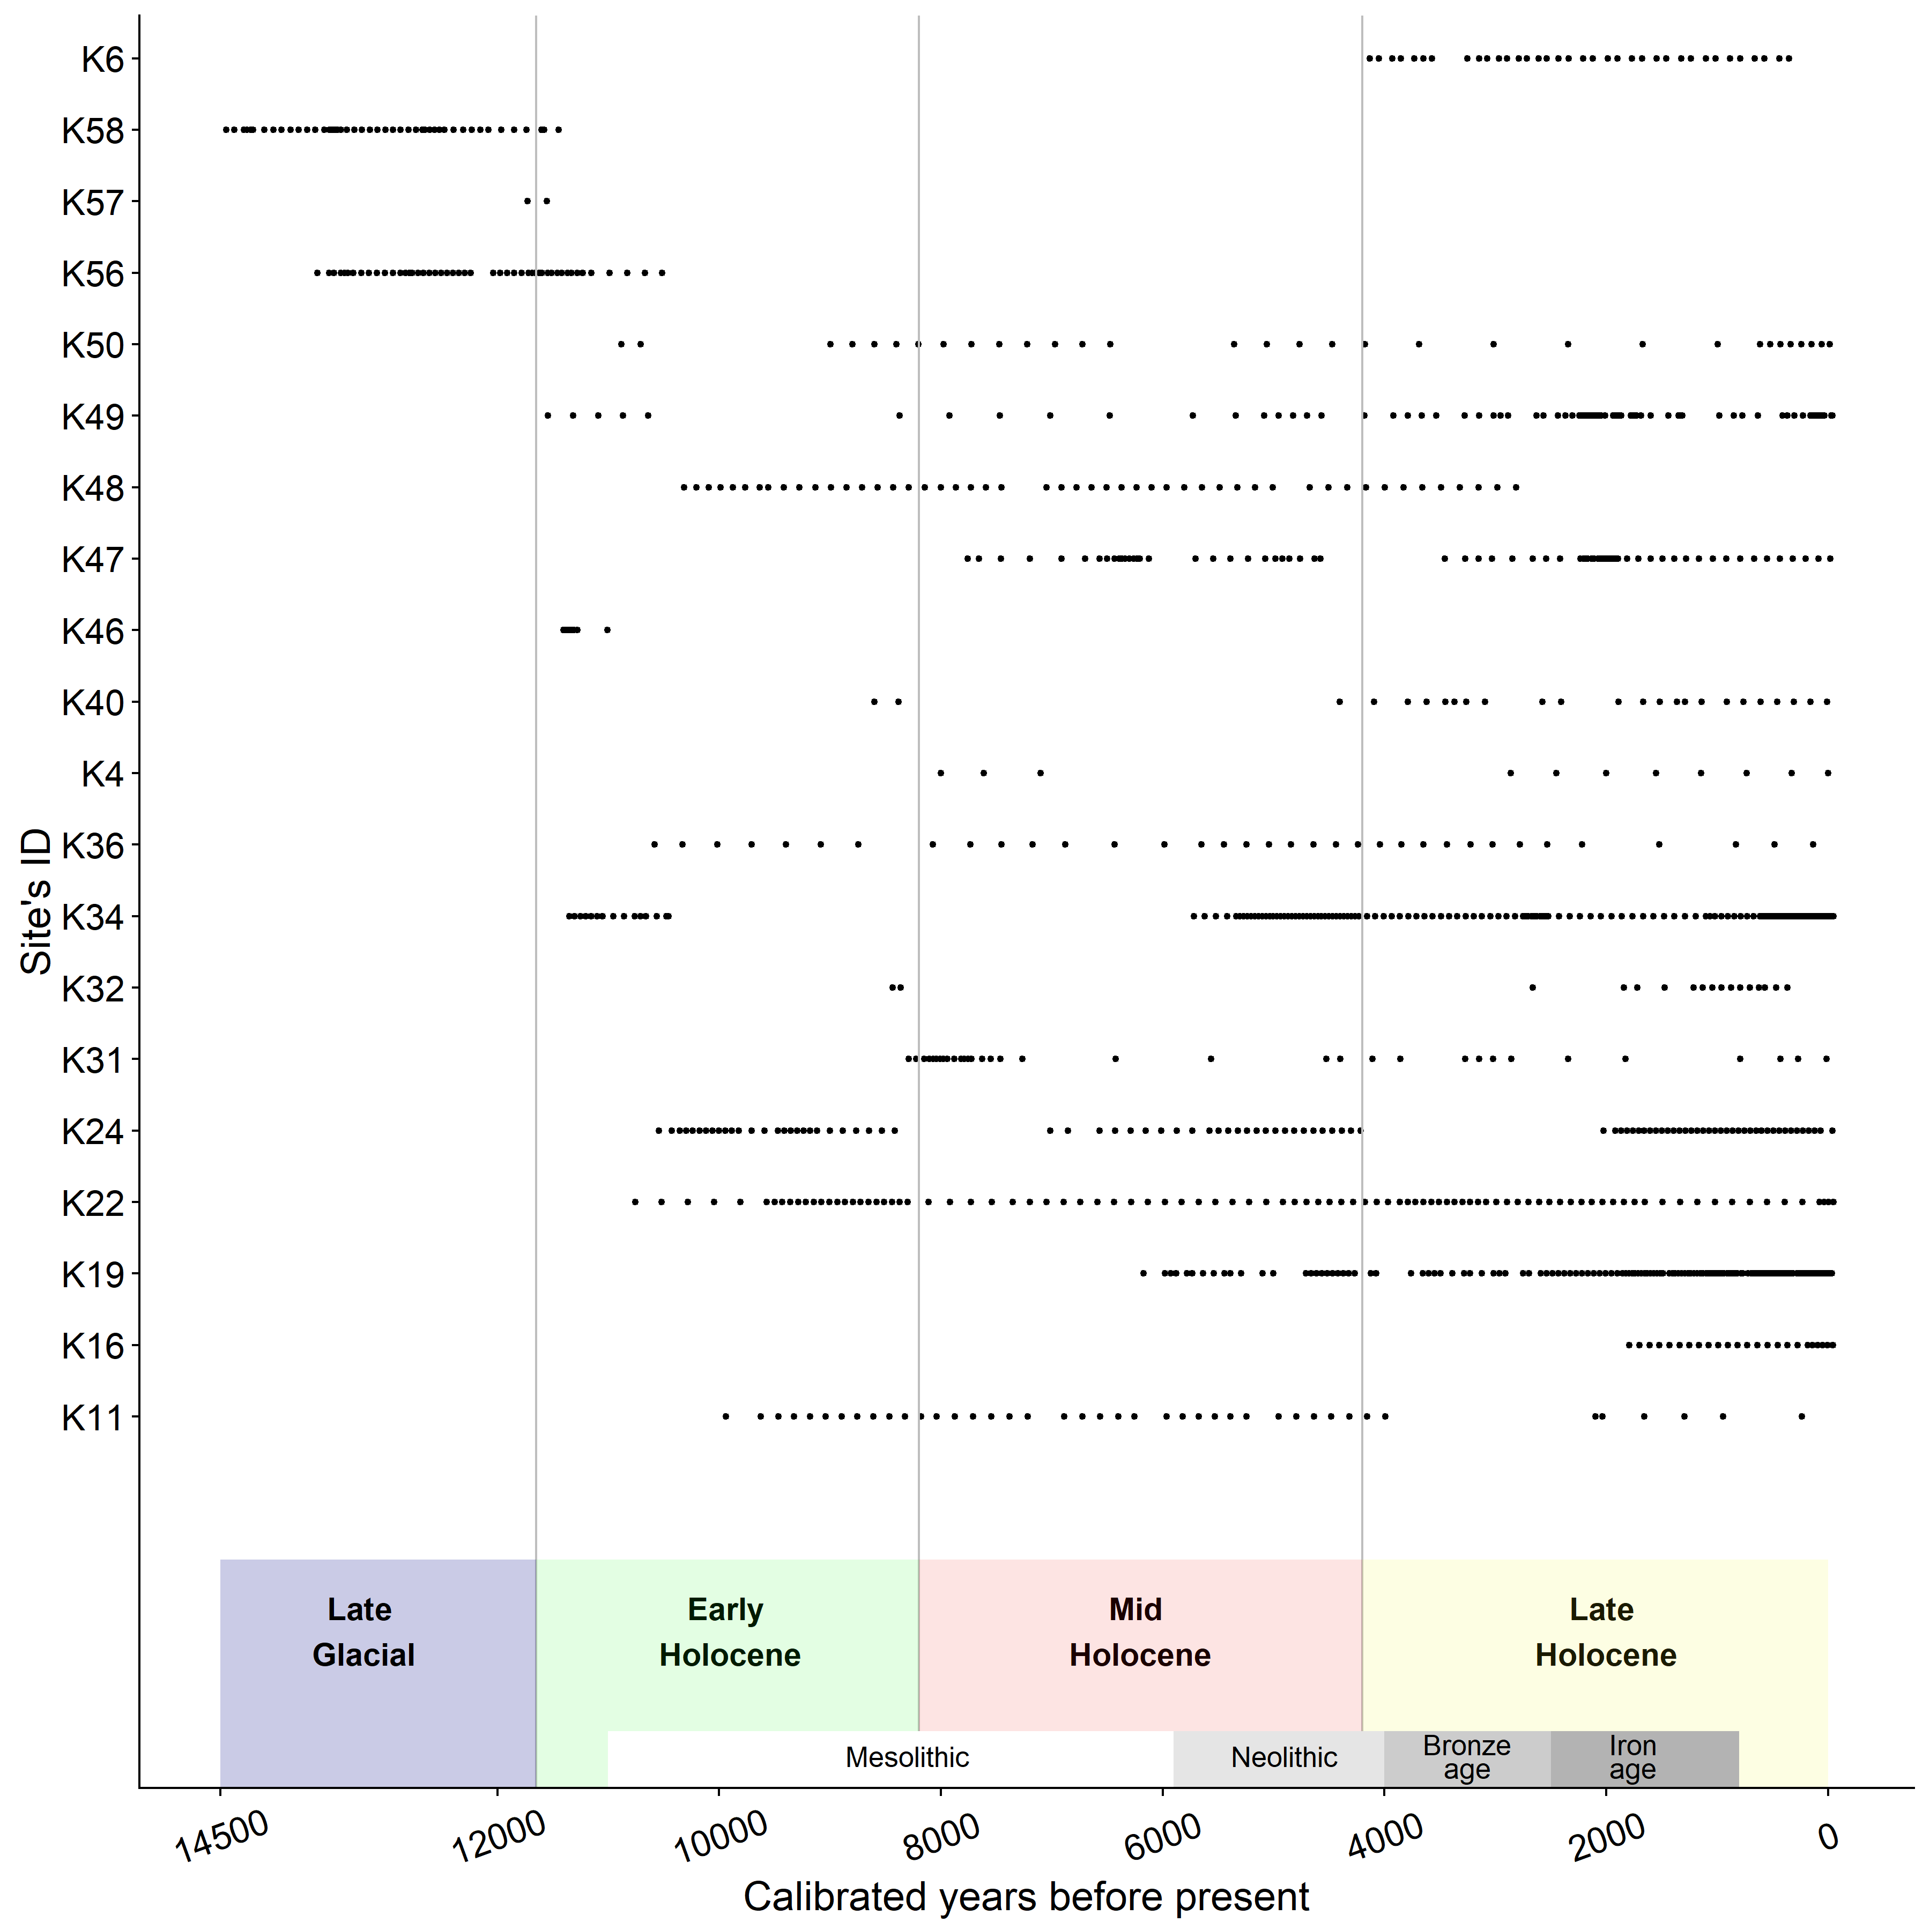

*Figure* *4.*  Temporal range cover per site, from 14500 years before present (cal. yr BP) until the present in Northern Europe.

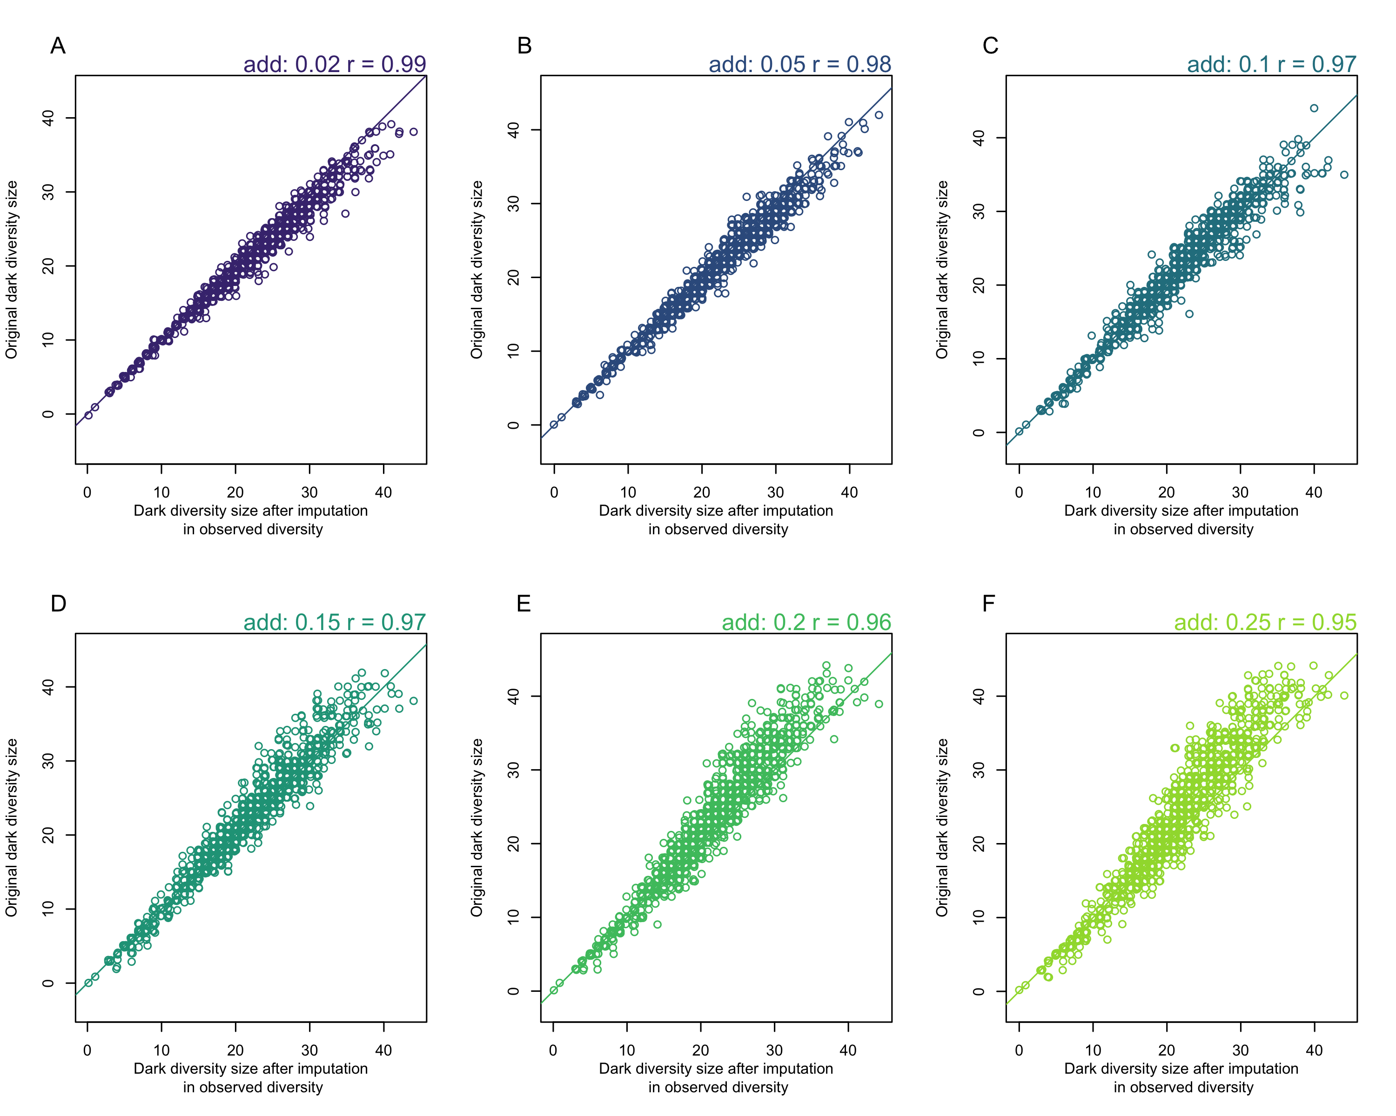

*Figure* *5.*  Correlation between original dark diversity and dark diversity results after randomly adding a percentage of highly suitable taxa to observed diversity (2%,5%,10%,15%,20%,25%). Even after adding 25% of highly suitable taxa to observed diversity, the correlation between the original dark diveristy size and the one after imputation is still high (95%), suggesting that sampling bias issue is minimal in our dark diversity results. The identity line is drawn on each graph.

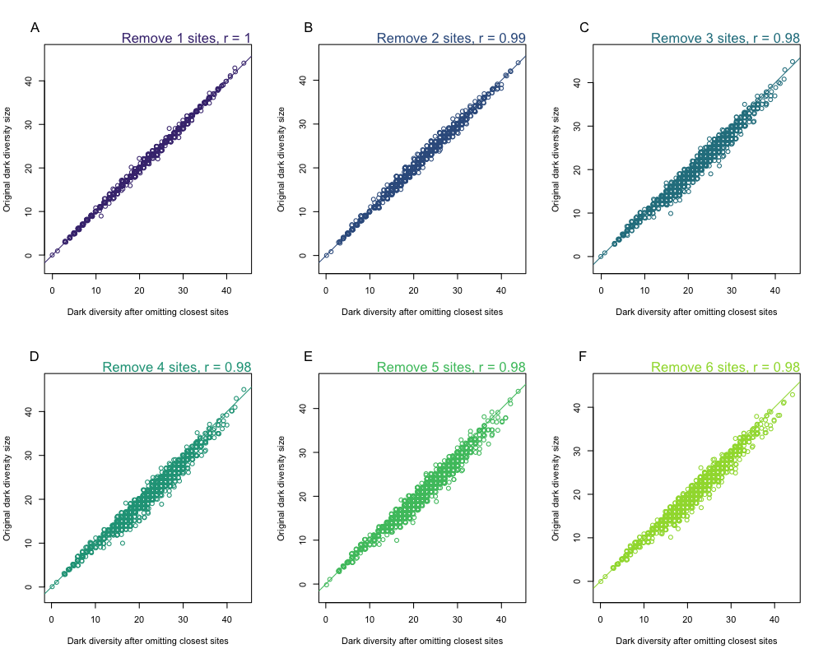

*Figure* *6.*  Correlation between original dark diversity and dark diversity results after removing closest sites (1-6 sites). The correlation between the original dark diveristy size and the dark diversity size after removing six closest sites is still high (98%), suggesting that autocorrelation issue is minimal in our dark diversity results. The identity line is drawn on each graph.

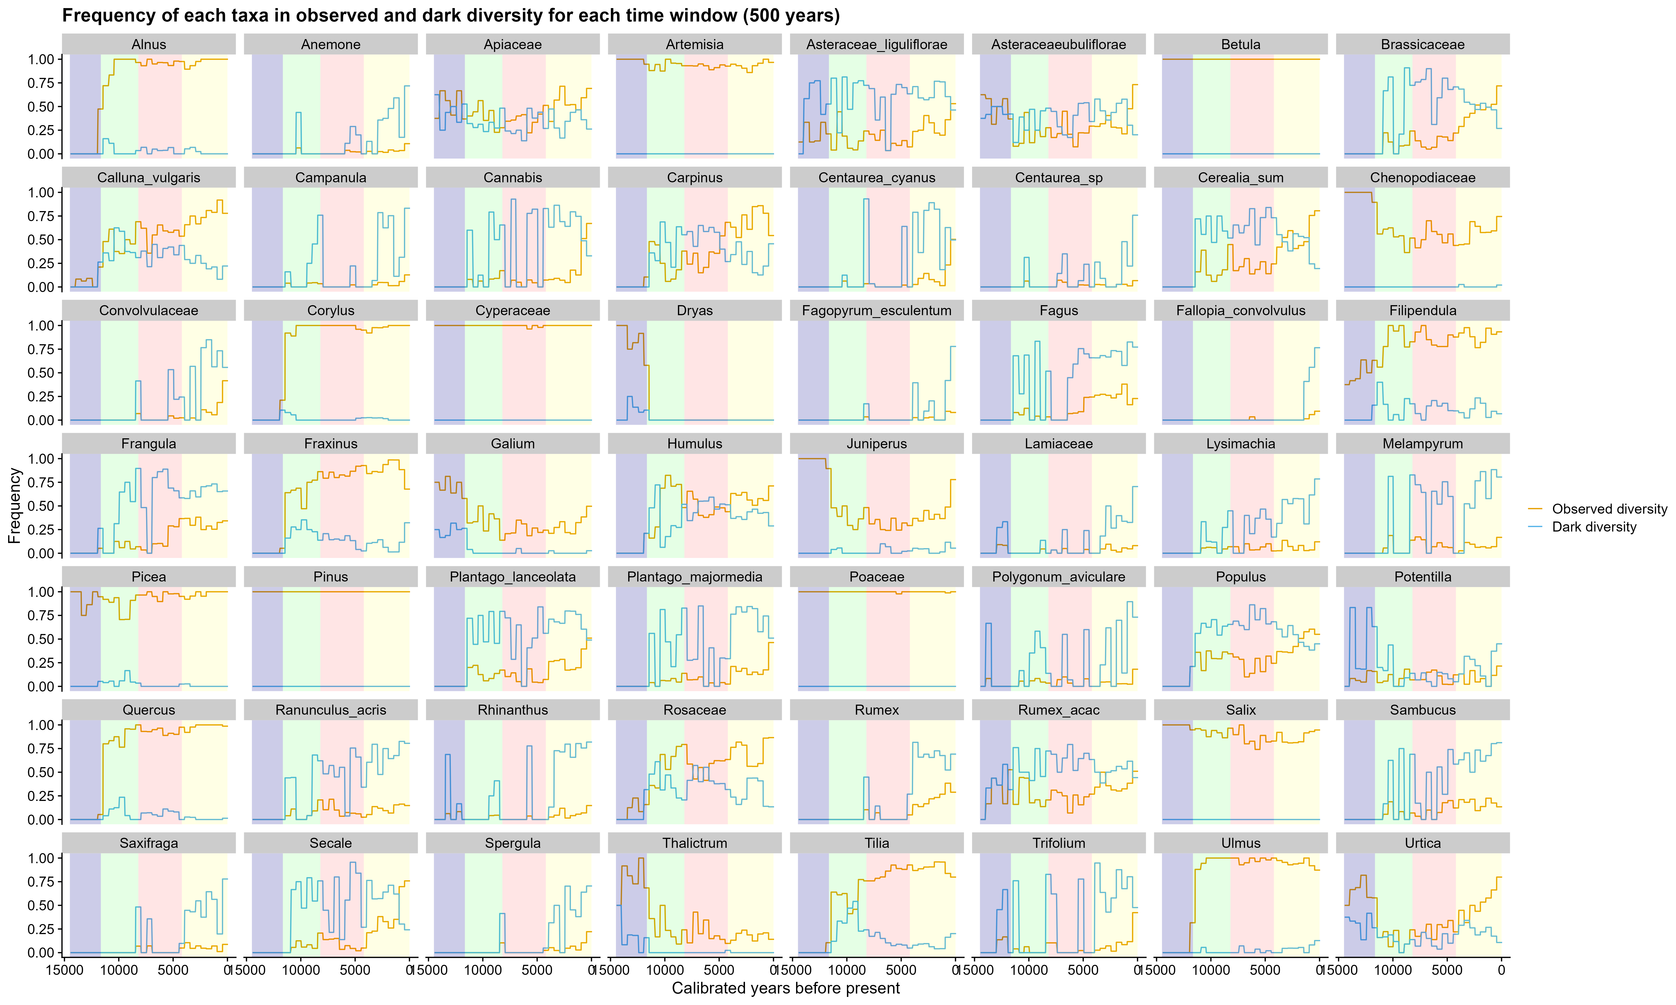

*Figure* *7.*  Relative frequency of taxa in observed and dark diversity from 14500 years before present (cal. yr BP) until the present. The relative frequency of taxa was calculated for each 500-year time window using the number of times taxa occupied a site (observed diversity) or were suitable but absent (dark diversity) divided by the number of sites at each time window. Only taxa with more than 30% of frequency either within observed or dark diversity in any time window are shown.

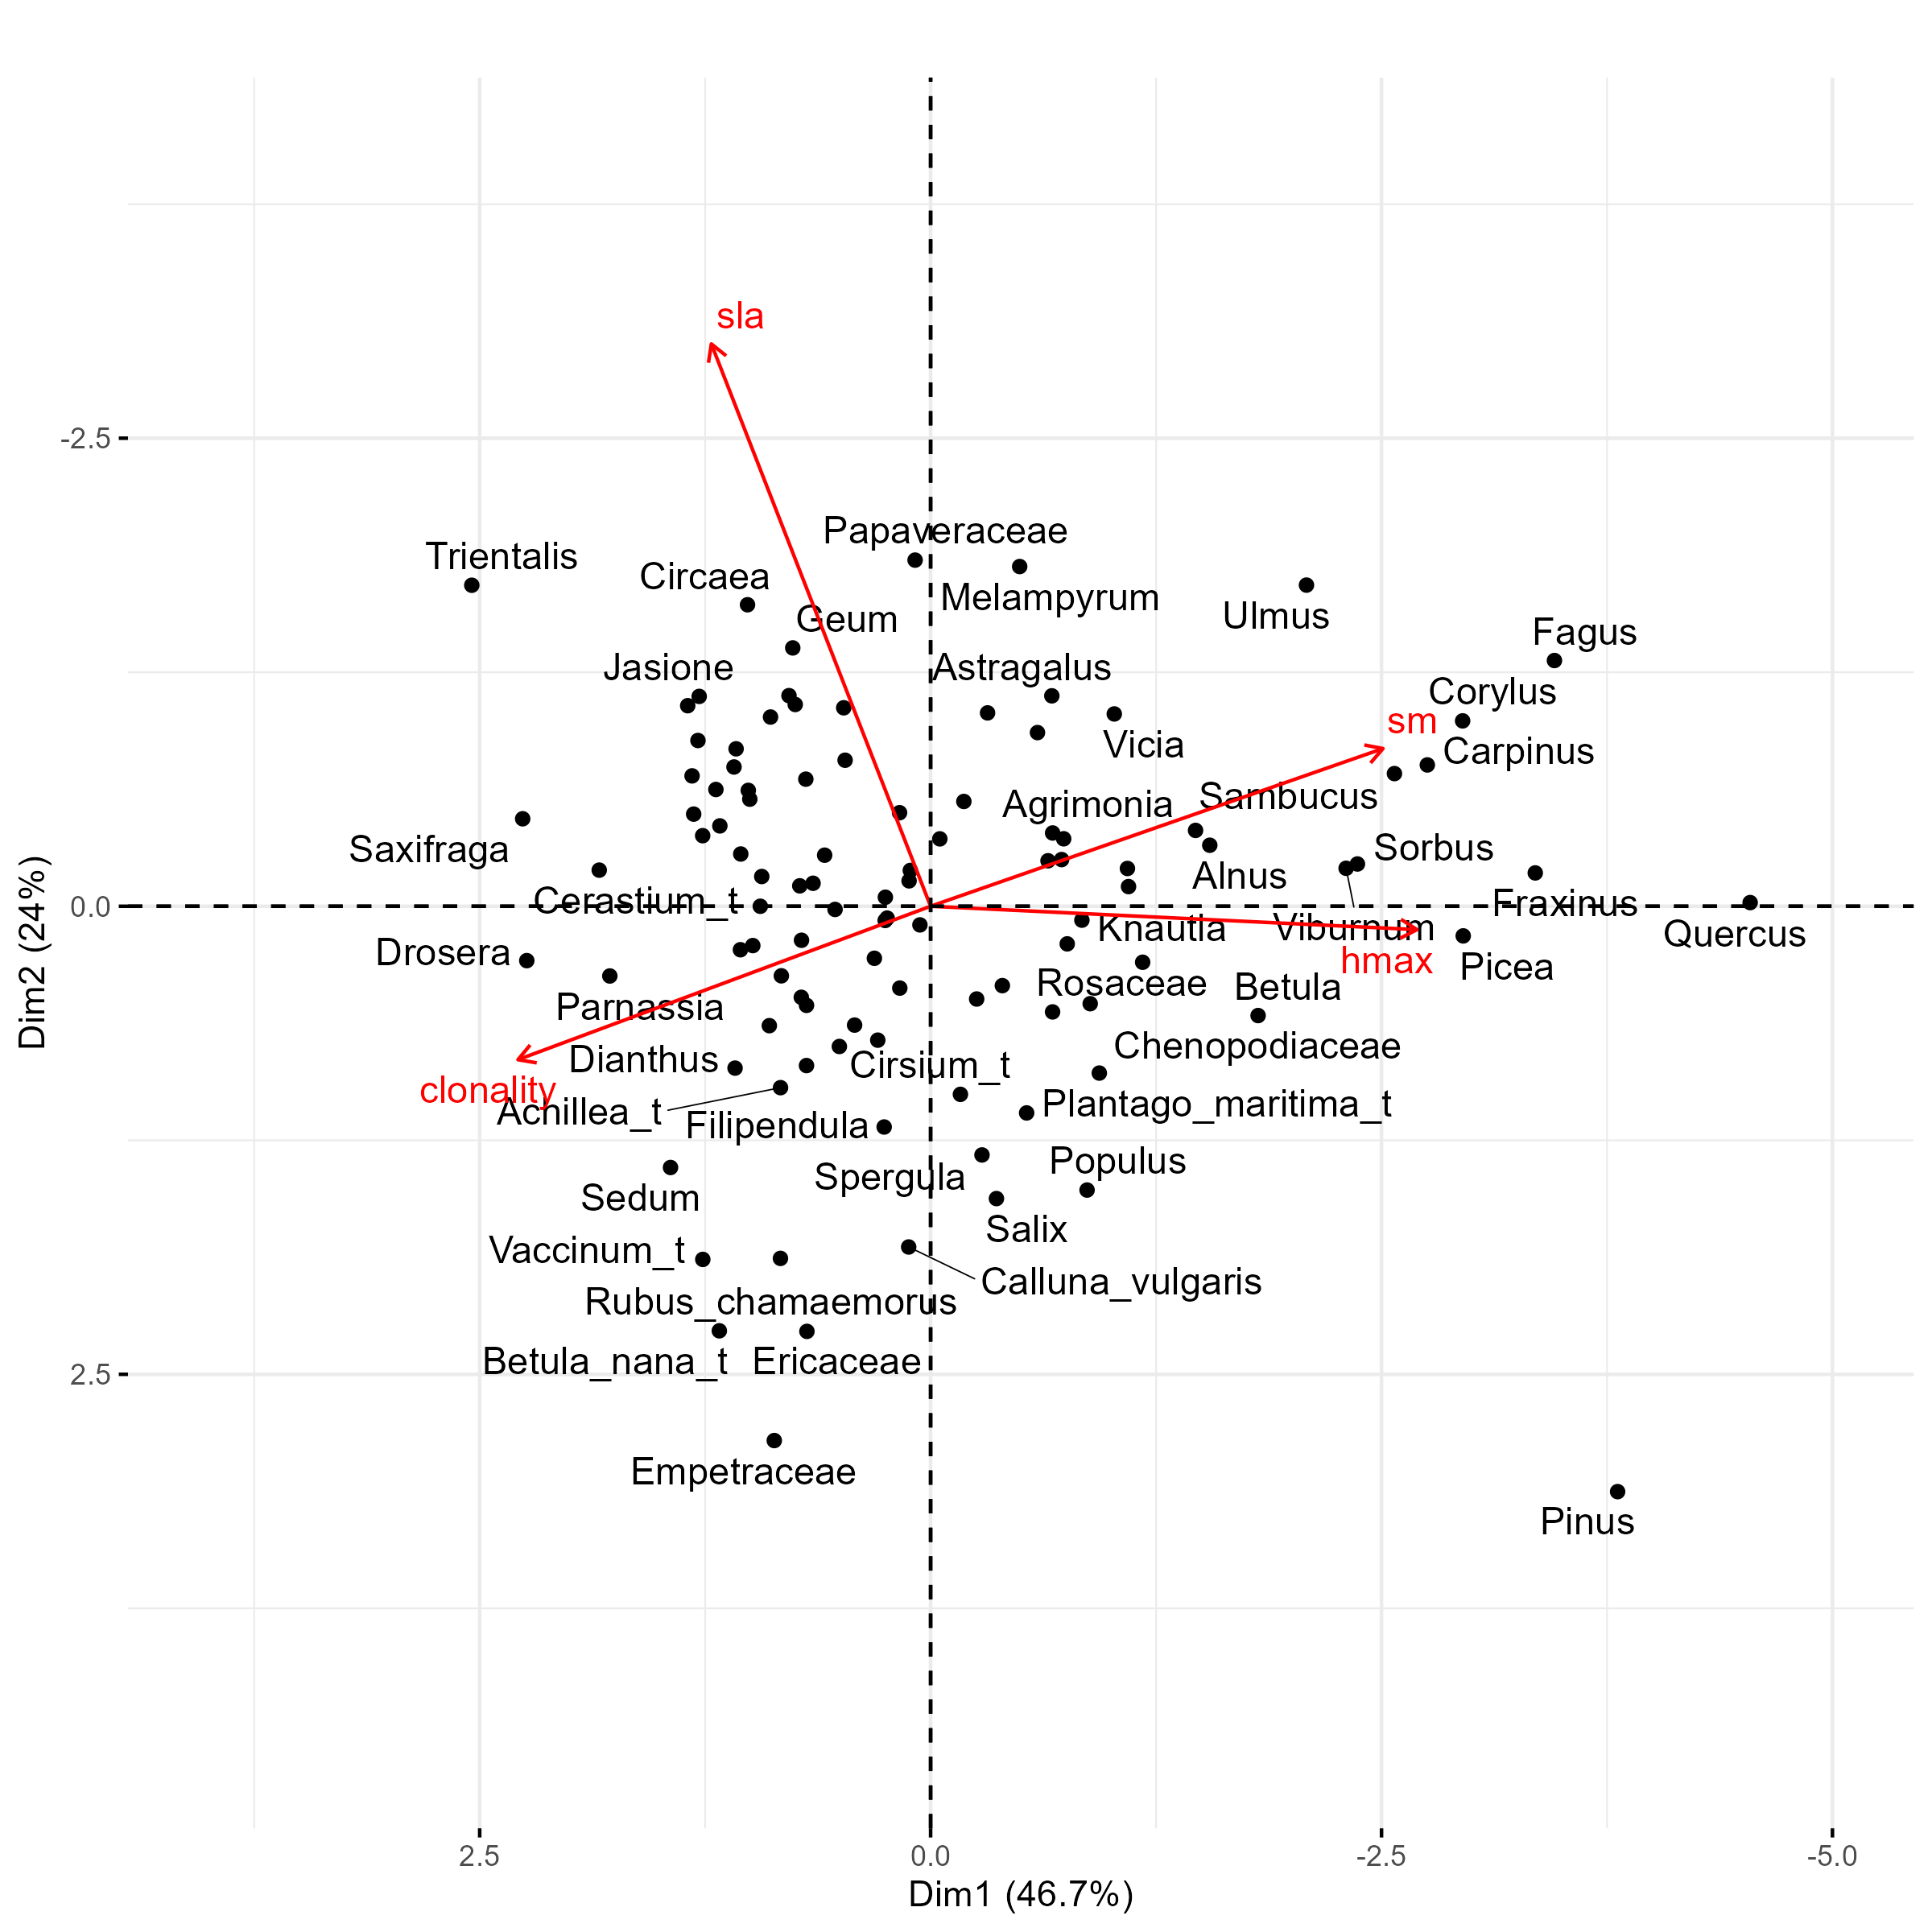

*Figure* *8.*  Principal component analysis of the functional spectra of plants in Northern Europe, depicting the first axis represented by Height (hmax), seed weight (sm) and clonality and the second axis represented by specific leaf area (sla) and pollination. The first axis (PC1) explains 45.1% of the total variation and the second axis (PC2) explains 19.3% of the total variation.

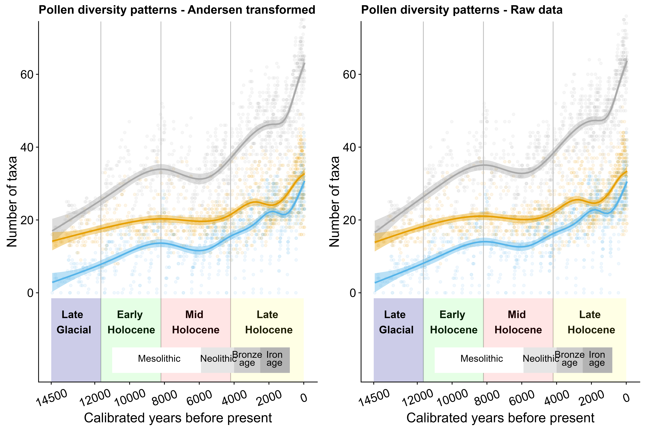

*Figure* *9.*  Comparison between Andersen transformed and raw pollen data, depicting that the diversity patterns in both datasets are similar. Number of taxa in both observed and dark diversity, as well species pool size of sites in NE Europe over the past 14500 years (cal. yr BP). Lines represent the fits of GAM and shaded areas the 95% confidence intervals.

Table 1: Table S2. Generalized additive model (GAM) results for the taxonomic observed and dark diversity and species pool size over the last 14500 years in Northern Europe.

|  |  |  |  |  |  |
| --- | --- | --- | --- | --- | --- |
| **Component** | **Term** | **Estimate** | **Std Error** | **t-value** | **p-value** |
| A. parametric coefficients | (Intercept) | 42.04 | 0.19 | 219.86 | <0.01 |
| divobs | -17.95 | 0.27 | -66.37 | <0.01 |
| divdark | -24.09 | 0.27 | -89.10 | <0.01 |
| **Component** | **Term** | **edf** | **Ref. df** | **F-value** | **p-value** |
| B. smooth terms | s(ybp):divpool | 8.88 | 8.99 | 386.88 | <0.01 |
| s(ybp):divobs | 8.80 | 8.98 | 72.35 | <0.01 |
| s(ybp):divdark | 8.35 | 8.78 | 133.67 | <0.01 |
| Adjusted R-squared: 0.81, Deviance explained 0.81 | | | | | |
| GCV: 39.19, Scale est.: 38.83, N: 3186 | | | | | |

Table 2: Table S3. Generalized additive model (GAM) results for the taxonomic community completeness over the last 14500 years in Northern Europe.

|  |  |  |  |  |  |
| --- | --- | --- | --- | --- | --- |
| **Component** | **Term** | **Estimate** | **Std Error** | **t-value** | **p-value** |
| A. parametric coefficients | (Intercept) | 0.37 | 0.02 | 22.26 | <0.01 |
| **Component** | **Term** | **edf** | **Ref. df** | **F-value** | **p-value** |
| B. smooth terms | s(ybp) | 8.06 | 8.59 | 29.51 | <0.01 |
| Adjusted R-squared: 0.19, Deviance explained 0.20 | | | | | |
| GCV: 0.28, Scale est.: 0.28, N: 1028 | | | | | |

Table 3: Table S4. Generalized additive model (GAM) results for the functional observed and dark diversity and species pool size over the last 14500 years in Northern Europe.

|  |  |  |  |  |  |
| --- | --- | --- | --- | --- | --- |
| **Component** | **Term** | **Estimate** | **Std Error** | **t-value** | **p-value** |
| A. parametric coefficients | (Intercept) | 31.62 | 0.07 | 471.21 | <0.01 |
| variableObserved | -3.60 | 0.09 | -37.90 | <0.01 |
| variableDark | -28.02 | 0.09 | -295.29 | <0.01 |
| **Component** | **Term** | **edf** | **Ref. df** | **F-value** | **p-value** |
| B. smooth terms | s(ybp):variablePool | 6.14 | 6.99 | 297.93 | <0.01 |
| s(ybp):variableObserved | 7.76 | 8.36 | 159.60 | <0.01 |
| s(ybp):variableDark | 8.19 | 8.68 | 13.69 | <0.01 |
| Adjusted R-squared: 0.97, Deviance explained 0.97 | | | | | |
| GCV: 4.82, Scale est.: 4.78, N: 3186 | | | | | |

Table 4: Table S5. Generalized additive model (GAM) results for the functional community completeness over the last 14500 years in Northern Europe.

|  |  |  |  |  |  |
| --- | --- | --- | --- | --- | --- |
| **Component** | **Term** | **Estimate** | **Std Error** | **t-value** | **p-value** |
| A. parametric coefficients | (Intercept) | 2.28 | 0.03 | 74.62 | <0.01 |
| **Component** | **Term** | **edf** | **Ref. df** | **F-value** | **p-value** |
| B. smooth terms | s(ybp) | 7.44 | 8.11 | 7.37 | <0.01 |
| Adjusted R-squared: 0.05, Deviance explained 0.06 | | | | | |
| GCV: 0.95, Scale est.: 0.94, N: 1011 | | | | | |

Table 5: Table S6. Generalized additive model (GAM) results for mean trait values (first axis of the PCA - Height, seed weight and clonality) in observed and dark diversity over the last 14500 years in Northern Europe.

|  |  |  |  |  |  |
| --- | --- | --- | --- | --- | --- |
| **Component** | **Term** | **Estimate** | **Std Error** | **t-value** | **p-value** |
| A. parametric coefficients | (Intercept) | -1.12 | 0.01 | -115.05 | <0.01 |
| divDark | 0.82 | 0.01 | 59.30 | <0.01 |
| **Component** | **Term** | **edf** | **Ref. df** | **F-value** | **p-value** |
| B. smooth terms | s(ybp):divObserved | 8.65 | 8.96 | 51.98 | <0.01 |
| s(ybp):divDark | 8.89 | 9.00 | 108.43 | <0.01 |
| Adjusted R-squared: 0.70, Deviance explained 0.70 | | | | | |
| GCV: 0.1, Scale est.: 0.1, N: 2083 | | | | | |

Table 6: Table S7. Generalized additive model (GAM) results for mean trait values (second axis of the PCA - SLA and insect-pollination) in observed and dark diversity over the last 14500 years in Northern Europe.

|  |  |  |  |  |  |
| --- | --- | --- | --- | --- | --- |
| **Component** | **Term** | **Estimate** | **Std Error** | **t-value** | **p-value** |
| A. parametric coefficients | (Intercept) | 0.30 | 0.01 | 40.95 | <0.01 |
| divDark | -0.39 | 0.01 | -37.38 | <0.01 |
| **Component** | **Term** | **edf** | **Ref. df** | **F-value** | **p-value** |
| B. smooth terms | s(ybp):divObserved | 7.92 | 8.69 | 40.24 | <0.01 |
| s(ybp):divDark | 7.57 | 8.49 | 32.33 | <0.01 |
| Adjusted R-squared: 0.50, Deviance explained 0.50 | | | | | |
| GCV: 0.06, Scale est.: 0.06, N: 2083 | | | | | |